Chapter 3.4

Study Guide

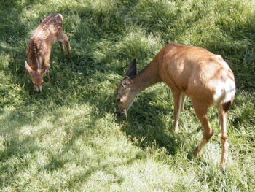 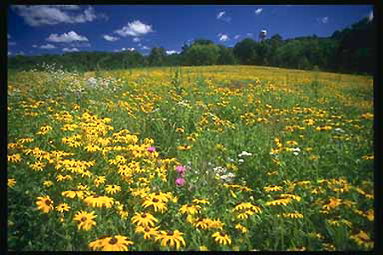

[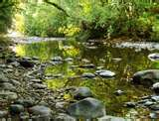](http://www.bing.com/images/search?q=creek#focal=2a9fdaa5e682f7562f68d43b84b9d8f5&furl=http://i.pbase.com/g3/28/638728/2/56074571.DSC021961.jpg)

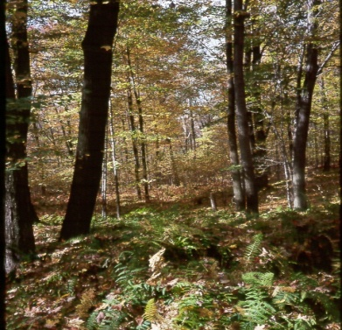 [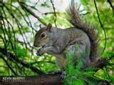](http://www.bing.com/images/search?q=squirrel#focal=18db0bbb540ba2a8df4700cac326753f&furl=http://kevoto.com/images/20081111214340_0036_grey_squirrel.jpg)

Ecosystem – a place where living and nonliving things exist and interact with each other

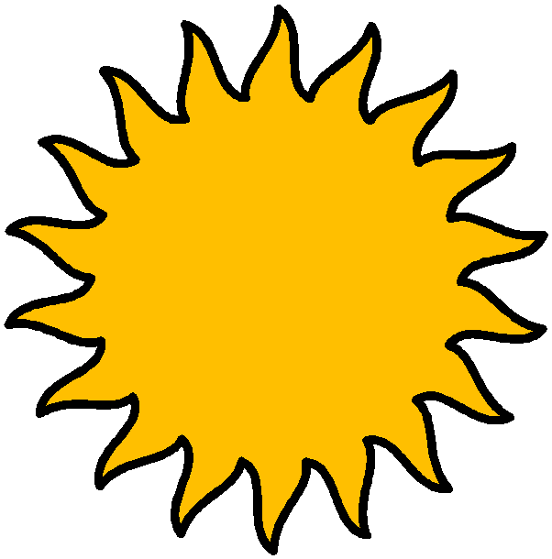 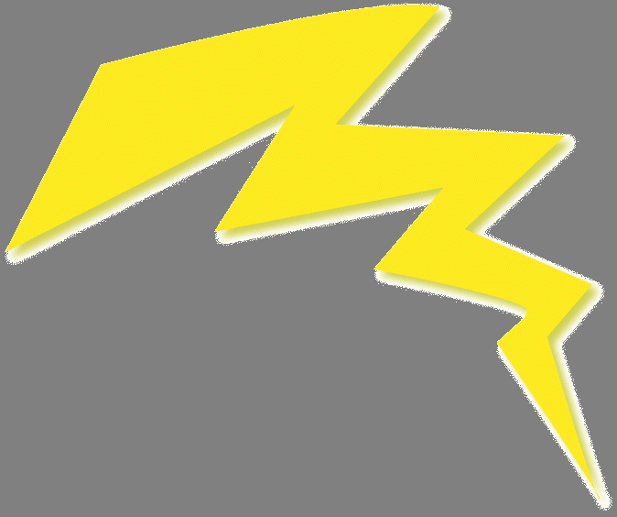

energy

Energy – the ability to cause change

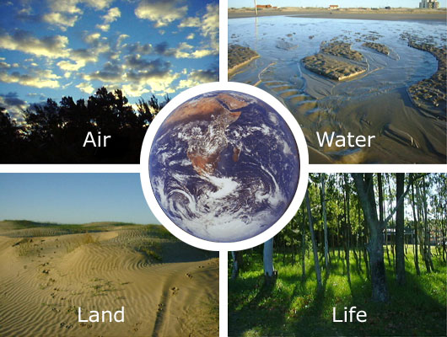



Environment – all the living and nonliving things that surround and affect an organism

[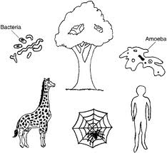](http://www.google.com/imgres?imgurl=http://01.edu-cdn.com/files/static/mcgrawhill-images/9780071410403/f0004-01.jpg&imgrefurl=http://www.education.com/study-help/article/biology-help-biology-organisms-order/&usg=__Rmbg_XuDCiBkbR13MoIGLj_Votg=&h=362&w=393&sz=50&hl=en&start=1&zoom=1&tbnid=pAoWBppOOx4SXM:&tbnh=114&tbnw=124&ei=YfjYTsnmHMrV0QH_lPXmDQ&prev=/search?q%3Dorganism%2Ba%2Bliving%2Bthing%26tbnh%3D173%26tbnw%3D188%26hl%3Den%26safe%3Dactive%26gbv%3D2%26sig%3D103401606922909726820%26biw%3D1280%26bih%3D719%26tbs%3Dsimg:CAESEgmkChYGmk47HiGxMbXXtqGWwA%26tbm%3Disch&itbs=1)

Organism – a living thing, such as a plant or animal

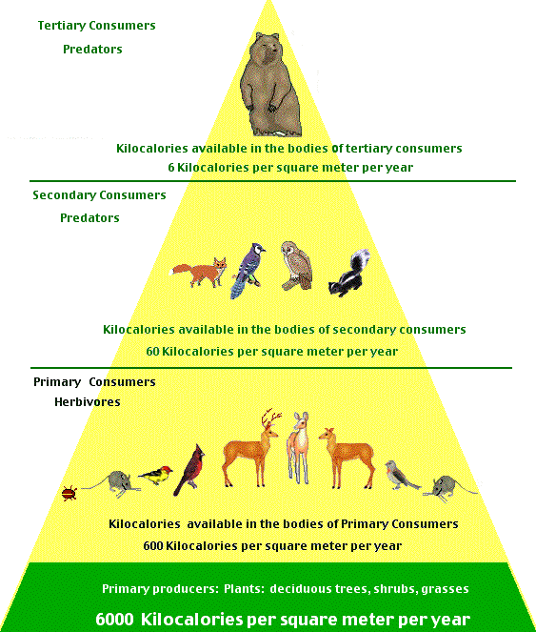

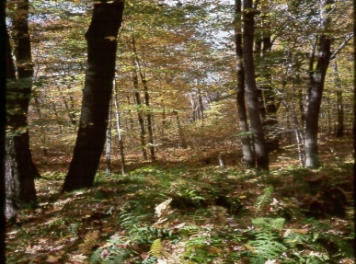

Community (Science) – a group of plants and animals that live in the same área and interact with each other

 

Population – all the organisms of the same kind that live together in an ecosytem

[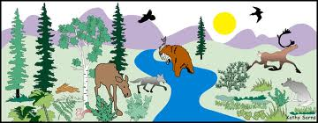](http://www.google.com/imgres?imgurl=http://igs-annessm.wikispaces.com/file/view/picture.jpg/35058953/picture.jpg&imgrefurl=http://igs-annessm.wikispaces.com/&usg=__AtsFNWw7SC2e3y5sQT8jAHvNpuY=&h=509&w=1306&sz=120&hl=en&start=1&zoom=1&tbnid=ynzlhnMpozL-4M:&tbnh=58&tbnw=150&ei=LAXZTu26BOno0QGEnJjlDQ&prev=/search?q%3Dbasic%2Bneeds%2Bof%2Bliving%2Bthings%26tbnh%3D100%26tbnw%3D257%26hl%3Den%26safe%3Dactive%26gbv%3D2%26sig%3D103401606922909726820%26biw%3D1280%26bih%3D719%26tbs%3Dsimg:CAESEgnKfOWGcymjMiFthGG4PreTjw%26tbm%3Disch&itbs=1)

air

water

food

Resource – a material or object found in nature, such as food, wáter, shelter and air that is useful to the organism.

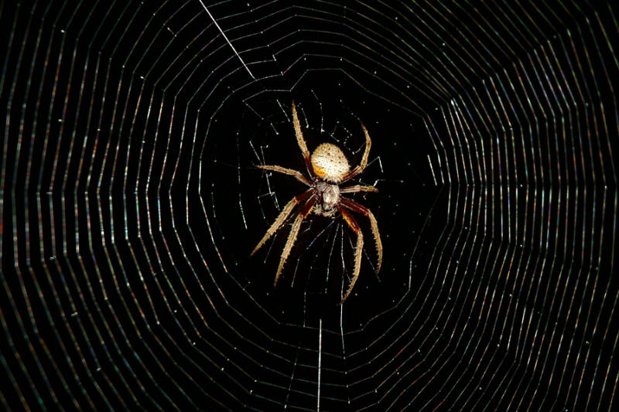 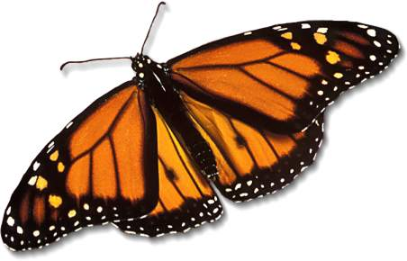

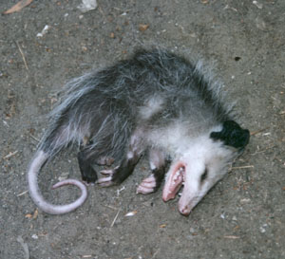 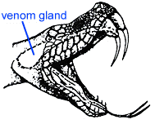

Adaptation – a behavior or body part of a living thing that helps it survive in its evironment.



Behavior – the way an animal typically acts in a certain situation